CREATE VIEW Skladnik AS

SELECT z.Meno, z.Priezvisko, z.Pohlavie, z.Vyplata, z.Zam_tel_c, z.Rola_zamestnanca, o.Nazov

FROM Zamestnanec as z, Oddelenie as o

Where z.ID_Zamestnanca = 5 AND o.ID_Zamestnanca = z.ID_Zamestnanca;

SELECT d.Nazov, d.Adresa, d.ICO, d.Dod_Tel_c, dl.Cena, dl.Datum, dl.Mnozstvo, dl.Merna_jednotka, m.Nazov, m.Merna_jednotka, m.Cena, m.Mnozstvo

FROM Dodavatel as d, Dodavaci_list as dl, Material as m

Where d.ID_Dodavatela = dl.ID_Dodavatela AND dl.ID_materialu = m.ID_materialu;

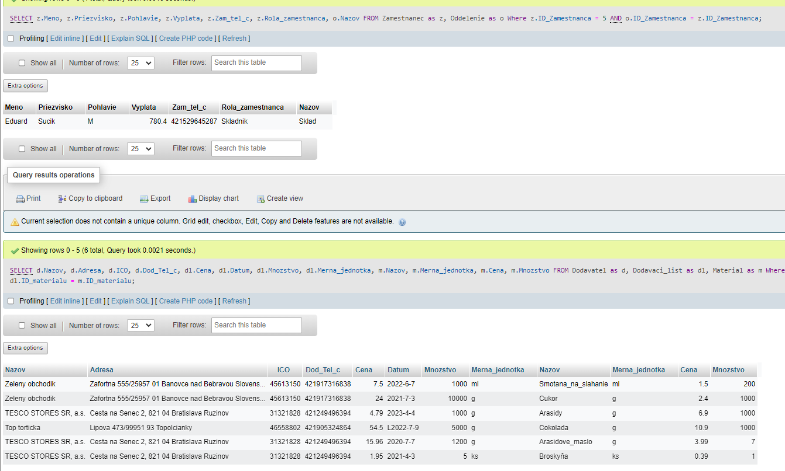

CREATE VIEW Kasa AS

SELECT z.Meno, z.Priezvisko, z.Pohlavie, z.Vyplata, z.Zam_tel_c, z.Rola_zamestnanca, o.Nazov

FROM Zamestnanec as z, Oddelenie as o

Where z.ID_Zamestnanca = 4 AND o.ID_Zamestnanca = z.ID_Zamestnanca;

SELECT v.Nazov, v.Predajna_cena, v.Marza, o.Cas, o.Mnozstvo, o.Cena, o.Celk_Cena, o.Cas, o.Mnozstvo, o.Cena, o.Celk_Cena, t.Cena, t.Cas, t.Typ_transakcie, p.Mnozstvo

FROM Objednavka as o, Transakcia as t, Vyrobok as v, Pokladnica as p

Where o.ID_objednavky = t.ID_transakcie AND t.ID_transakcie = p.ID_Pokladnice AND v.ID_Vyrobku = o.ID_objednavky;

